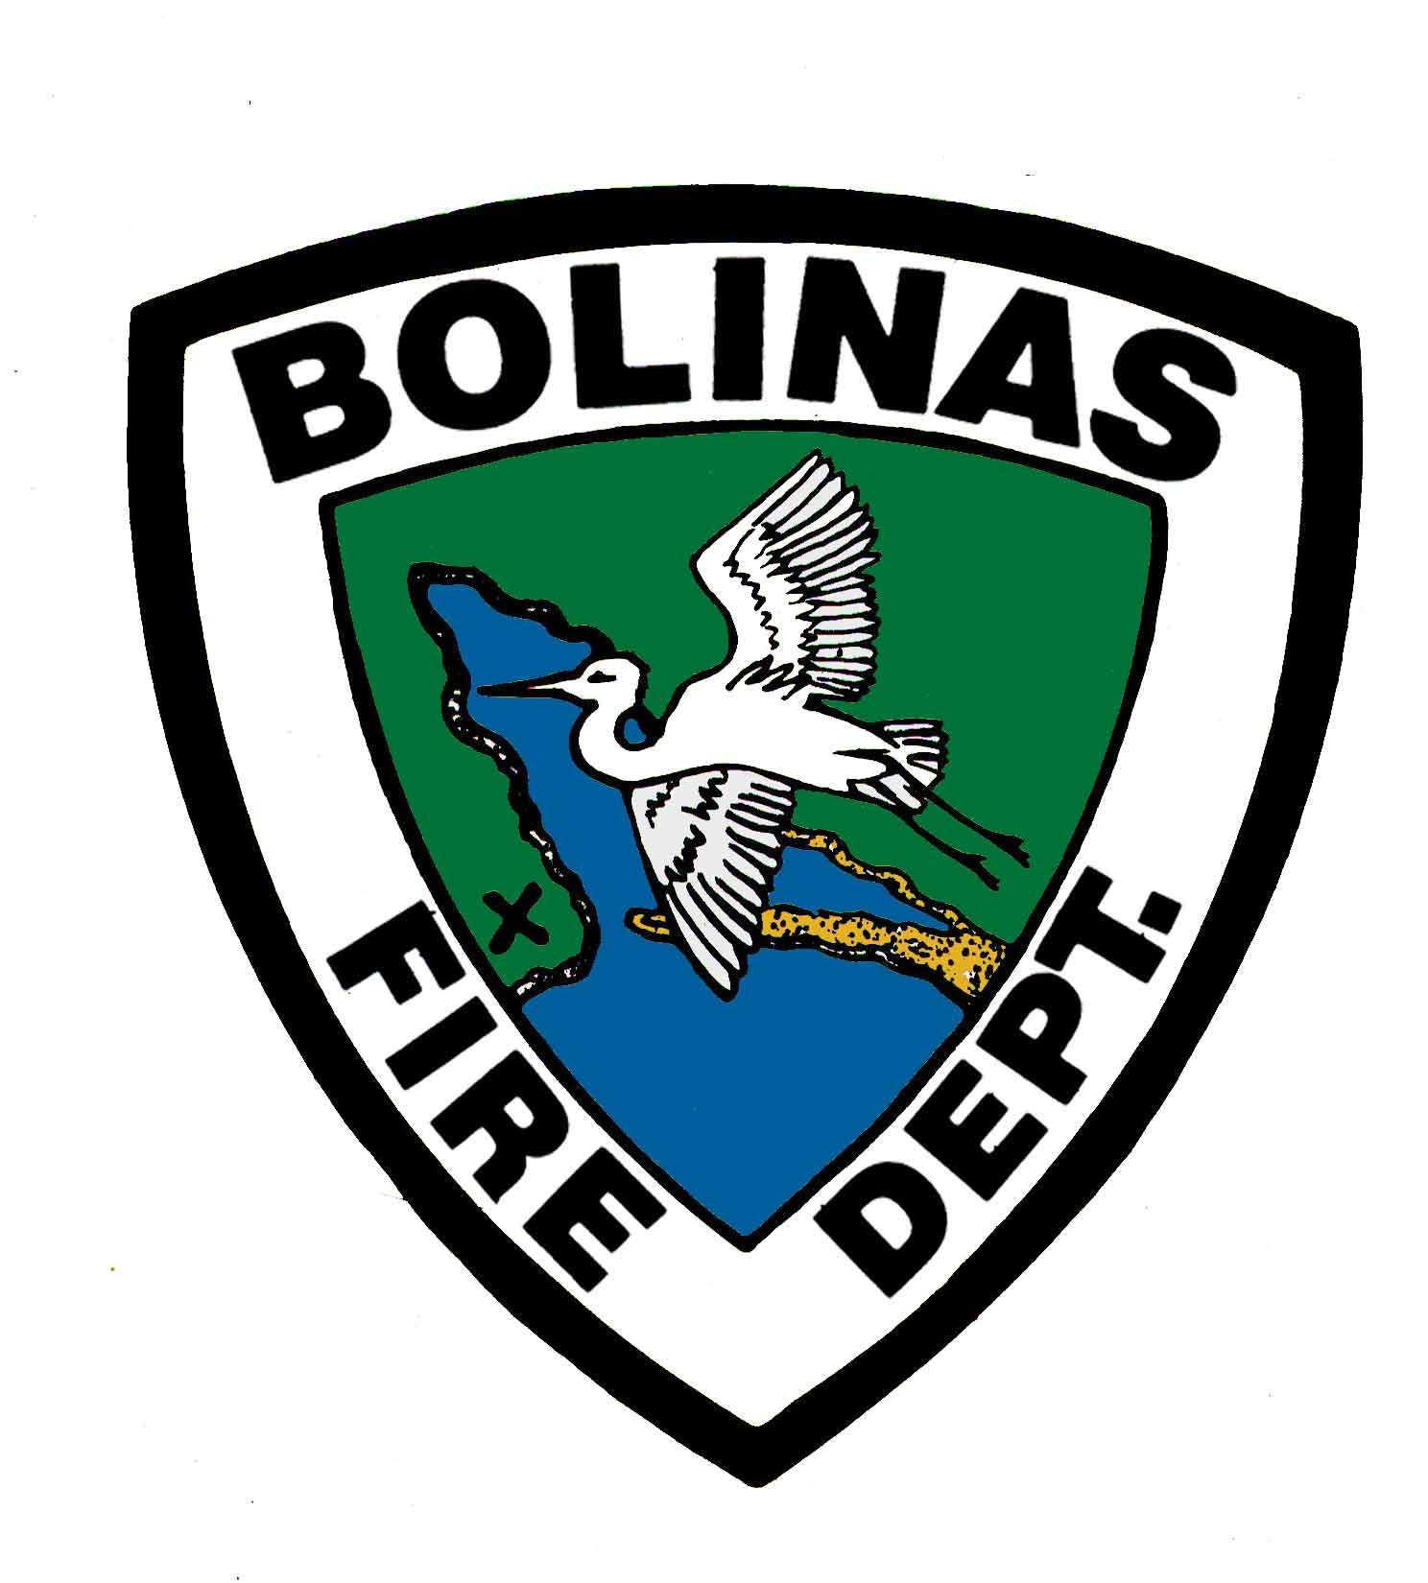
Bolinas Fire Protection District
P.O. Box 126 | 100 Mesa Road | Bolinas, CA 94924
415-868-1566 | fax 415-868-2009
www.bolinasfire.org

EMPLOYMENT APPLICATION

Position you are applying for: Social Security Number _ _ _-_ _-_ _ _ _
Disclosure of your Social Security
Number is voluntary. It will be
Full Time Duty Officer Firefighter/EMT
for identification purposes only to ensure proper records are maintained

Last Name_______________________________________________
First Name________________________________________ MI____
Mailing Address___________________________________________
City_____________________________________________________
State_____________ Zip Code__________________
Home Phone _ _ _-_ _ _-_ _ _ _ Mobile Phone _ _ _-_ _ _-_ _ _ _
E-Mail Address____________________________________________
Emergency Contact________________________ Phone Number________________
Relationship_______________________________

Bilingual Ability
Please list languages (other than English) in which you are fluent and mark applicable skill(s).
1._________________________________ Speak Only __ Speak/Read/Write __
2._________________________________ Speak Only __ Speak/Read/Write __

Additional Personal Information
Have you ever been discharged or resigned in lieu of discharge? Yes __ No __
If yes, please explain and include date and company discharged from.
________________________________________________________________________________________________________________________________________________________________________________________________________________________________________________________________________________________________________________________

Education/Background
High School Graduate Yes __ No __ If no, passed High School Equivalency Tests? Yes __ No __
Highest Grade Completed 1 __2 __3 __4 __5 __6 __7 __8 __ College 1 __2 __3 __4 __
Post Graduate Work 1 __2 __3 __4 __
Education and Experience
Name and location of College, University, Business
Correspondence, Trade or Service Schools
 | Course of Study | Degree Awarded | Completed Sem Units | Completed Qtr Units | Did you graduate?
Yes __
No __ Attending__
Yes __
No __Attending__
Yes __
No __Attending__
Yes __
No __Attending__

Are you at least 18 years of age? Yes __ No __
Are you a U.S. Citizen, or legally authorized to work in the United States? Yes __ No __
Are any relatives currently working for the Bolinas Fire Protection District? Yes __ No __
If yes, please list name and relationship.________________________________________

Please provide any additional information relevant to the position.
____________________________________________________________________________________________________________________________________________________________________________________________________________________________________________________________________________________________________________________________________________________________________________________________________________________________________________________________________________________

Work Experience
List complete employment history, beginning with most recent. Include paid or unpaid experience.

Employer________________________________________ Contact Number________________
Address____________________________________________________
Supervisor’s Name____________________________ Supervisor’s Title ___________________
Your Job Title________________________________
Specific Duties
______________________________________________________________________________
______________________________________________________________________________
______________________________________________________________________________
May we contact this employer? Yes __ No __ If no, please indicate reason: ________________
______________________________________________________________________________
Dates Employed (MO/YR) From _____ To _____ Total (Years/Months) _____
__________ __________ Reason for leaving __________________________________________
_____________________________________________________________________________

Employer________________________________________ Contact Number________________
Address____________________________________________________
Supervisor’s Name____________________________ Supervisor’s Title ___________________
Your Job Title________________________________
Specific Duties
______________________________________________________________________________
______________________________________________________________________________
______________________________________________________________________________
May we contact this employer? Yes __ No __ If no, please indicate reason: ________________
______________________________________________________________________________
Dates Employed (MO/YR) From _____ To _____ Total (Years/Months) _____
__________ __________ Reason for leaving __________________________________________
_____________________________________________________________________________

Employer________________________________________ Contact Number________________
Address____________________________________________________
Supervisor’s Name____________________________ Supervisor’s Title ___________________
Your Job Title________________________________
Specific Duties
______________________________________________________________________________
______________________________________________________________________________
______________________________________________________________________________
May we contact this employer? Yes __ No __ If no, please indicate reason: ________________
______________________________________________________________________________
Dates Employed (MO/YR) From _____ To _____ Total (Years/Months) _____
__________ __________ Reason for leaving __________________________________________
_____________________________________________________________________________

Employer________________________________________ Contact Number________________
Address____________________________________________________
Supervisor’s Name____________________________ Supervisor’s Title ___________________
Your Job Title________________________________
Specific Duties
______________________________________________________________________________
______________________________________________________________________________
______________________________________________________________________________
May we contact this employer? Yes __ No __ If no, please indicate reason: ________________
______________________________________________________________________________
Dates Employed (MO/YR) From _____ To _____ Total (Years/Months) _____
__________ __________ Reason for leaving __________________________________________
_____________________________________________________________________________

Employer________________________________________ Contact Number________________
Address____________________________________________________
Supervisor’s Name____________________________ Supervisor’s Title ___________________
Your Job Title________________________________
Specific Duties
______________________________________________________________________________
______________________________________________________________________________
______________________________________________________________________________
May we contact this employer? Yes __ No __ If no, please indicate reason: ________________
______________________________________________________________________________
Dates Employed (MO/YR) From _____ To _____ Total (Years/Months) _____
__________ __________ Reason for leaving __________________________________________
_____________________________________________________________________________

Please list three references (not relatives) that you have worked for or who can attest to your work qualities.

Name | Relationship | Contact Number

I hereby certify that the statements in this application are true. I request, authorize and consent to investigation by the Bolinas Fire Protection District of all statements contained in this application. I understand that falsification, misrepresentation or omission of facts called for may result in immediate removal of my application for consideration or immediate discharge from employment arising from this application. I request and authorize the Bolinas Fire Protection District to secure information related to this application and my experience, certification and/or licensure from former employers, personal and professional references, educational institutions, sources of certification or licensing, and governmental/judicial agencies. I specifically request, authorize and consent to the Bolinas Fire Protection District’s thorough investigation of whether I have a record of criminal conviction, and if so, the nature of such criminal conviction and all surrounding circumstances available through lawful means, including providing my fingerprints to the District to facilitate this investigation. The Bolinas Fire Protection District has advised me that its criminal background check will focus on convictions and that a criminal record will not necessarily disqualify me from employment. I request, authorize and consent to the foregoing parties to provide the requested information to the Bolinas Fire Protection District and release them and the Bolinas Fire Protection District from any liability arising there from.

I am aware that the Bolinas Fire Protection District may obtain public records regarding me for employment purposes, including but not limited to evaluation for employment, assignment, and/or promotion.

I acknowledge that the term public records as used herein are limited to records of arrest, indictment, conviction, civil judicial action, tax lien, or outstanding judgment.

Check one line only:

___ I hereby elect to receive any public records, which may be obtained by the Bolinas Fire Protection District for employment purposes under Civil Code 1786.53.

___ I hereby elect not to receive any public records, which may be obtained by the Bolinas Fire Protection District for employment purposes under Civil Code 1786.53.

Date_______________ Applicant’s Signature________________________________________

Print Name____________________________________________________________________

Equal Employment Opportunity Employer: The Bolinas Fire Protection District is committed to diversity and invites all qualified people to apply, including persons of color, women, and individuals with disabilities. Upon request, reasonable accommodations may be made for persons with disabilities and for religious reasons, where necessary. If you have questions regarding equal employment opportunities or the position announcement, please contact the District Administrative Office at (415) 868-1566.

